After creating Instance -- open instance and click on connect and then go to RDP client

Download remote desktop file and open as shown below. 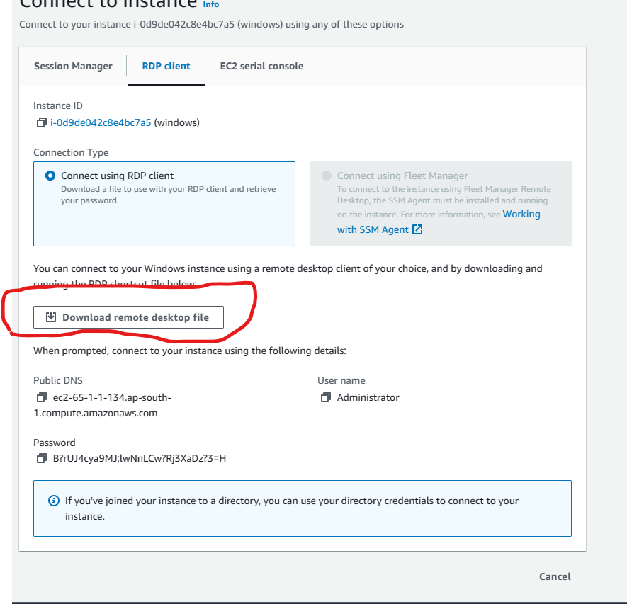

Opwn downloaded RDC and username and AMI is already filled –click on connect and enter password and press ok.

**now login to windows instance is successful.**